Screenshots of website

In this document you will find screenshots with descriptions of the website

In my website I managed to assemble all the functionality that was requested in only one page. I thing this makes things simpler as the user can do everything in one place and not worry about remembering which page is for what.

1. 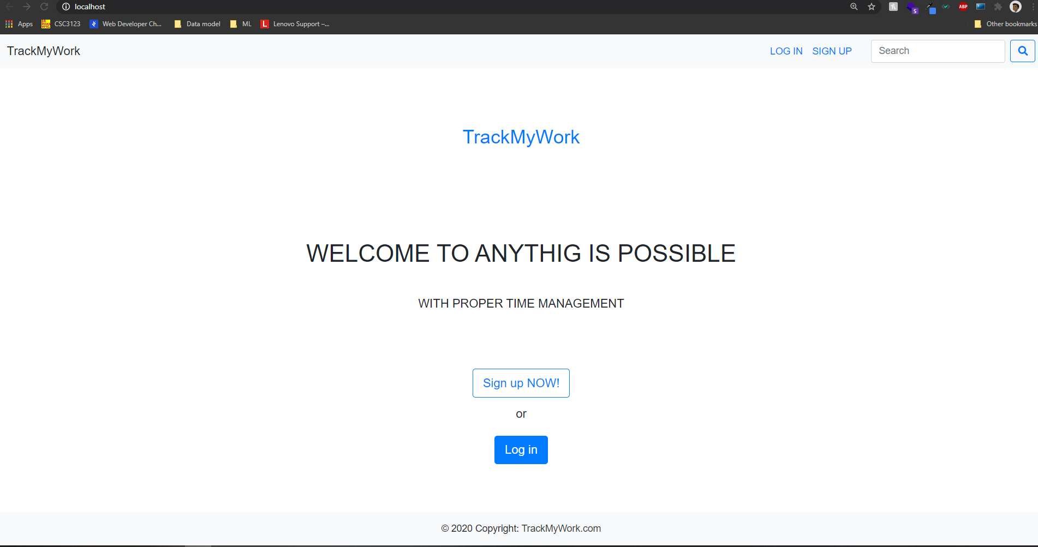This is the landing page of the website.

It welcomes you to the website and allows you to Sign up or Log in.

1. 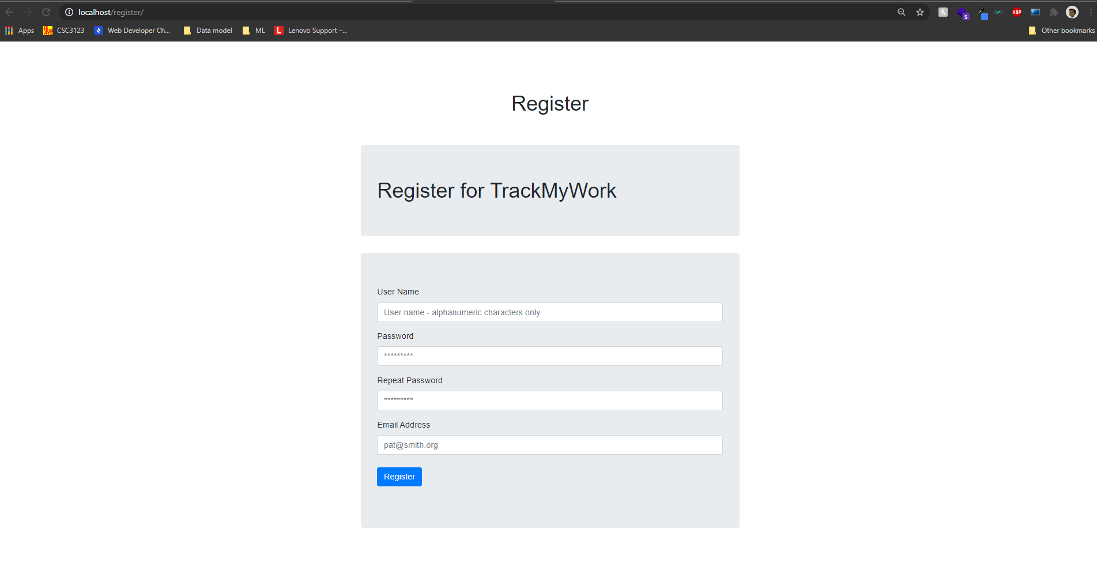

This is the Register page that allows you to register

1. 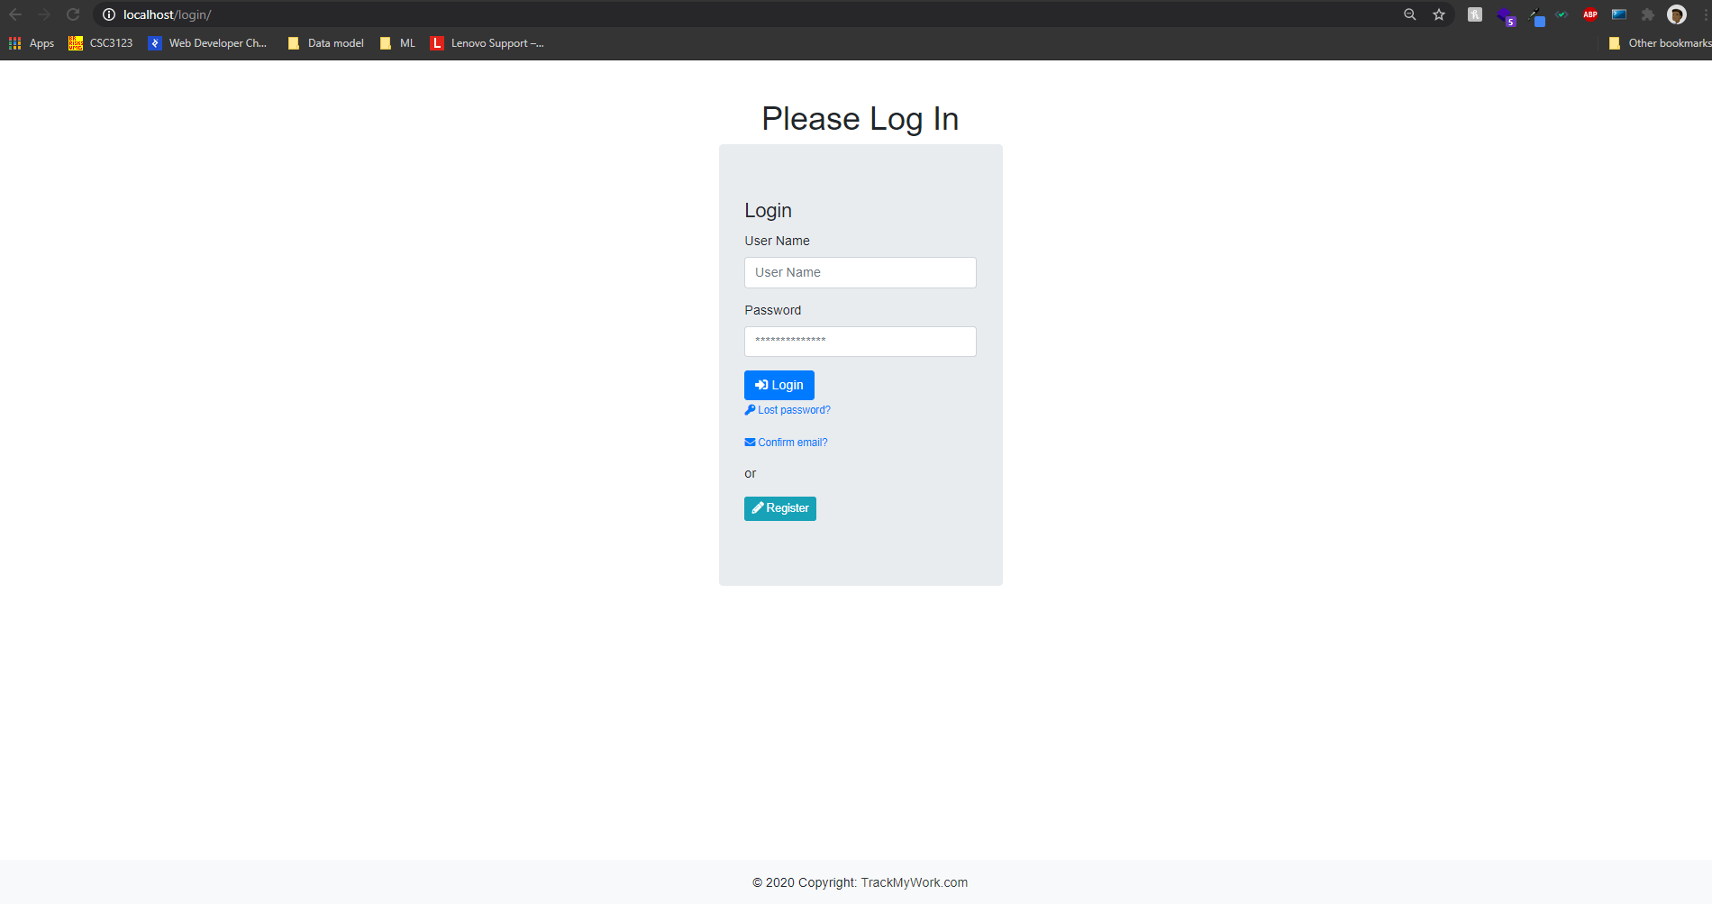

After you have an account you can log in using it.

Here I am going to be loging it as admin

User:admin

Password:admin

1. After logging in this is the landing page

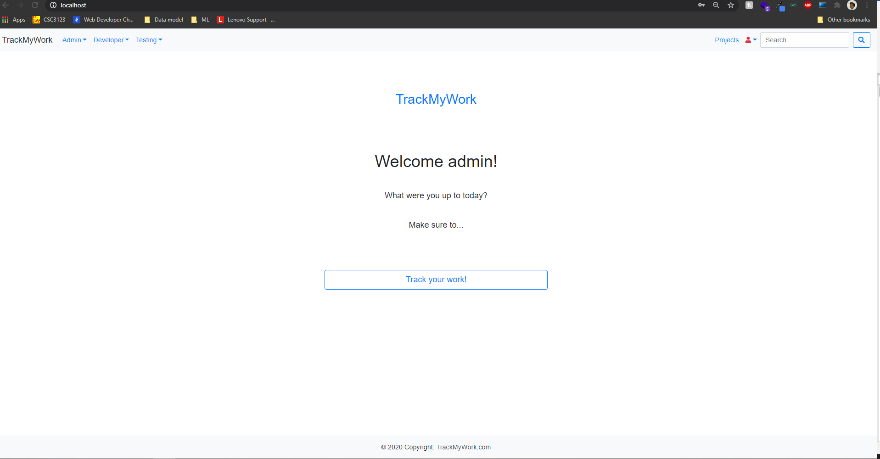

Here you can go and start tracking your work.(go to the projects tab)

1. 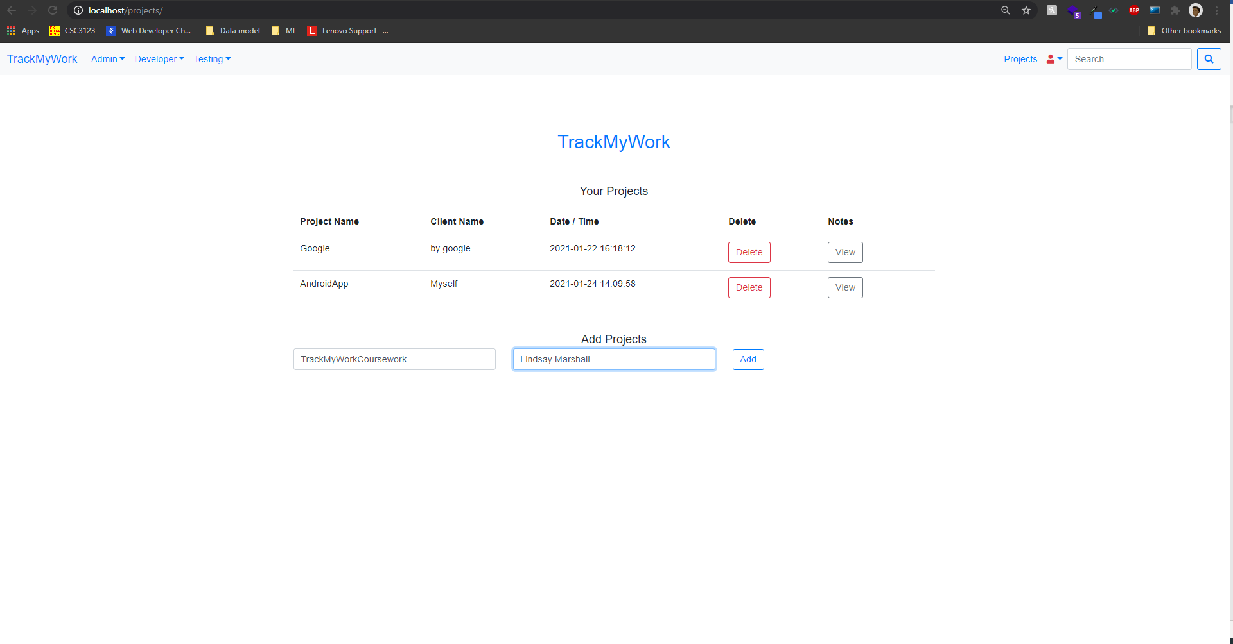

In the projects tab you can look at your projects and add new projects by filling up the form and clicking the add button.

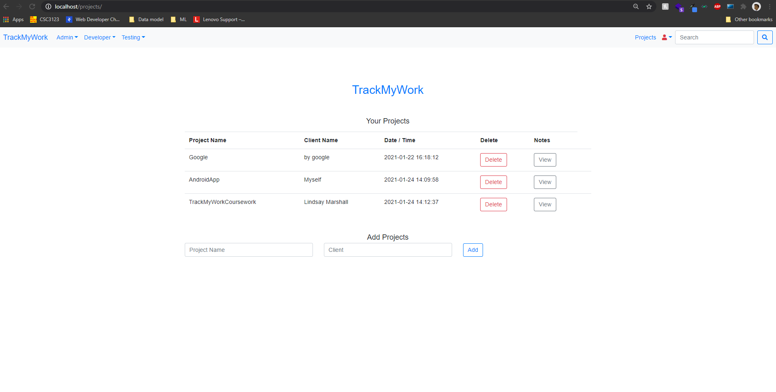

Here I added a new project called TrackMyWorkCoursework.

You can allso add notes to your projects and attach files to them:

Do this by clicking the view Notes button to toggle a modal that shows all your notes for the current project and allows you to add new notes and attach files to them.

Note: you can only upload word documents,pdfs, and pictures you cant upload zip or anithing else.

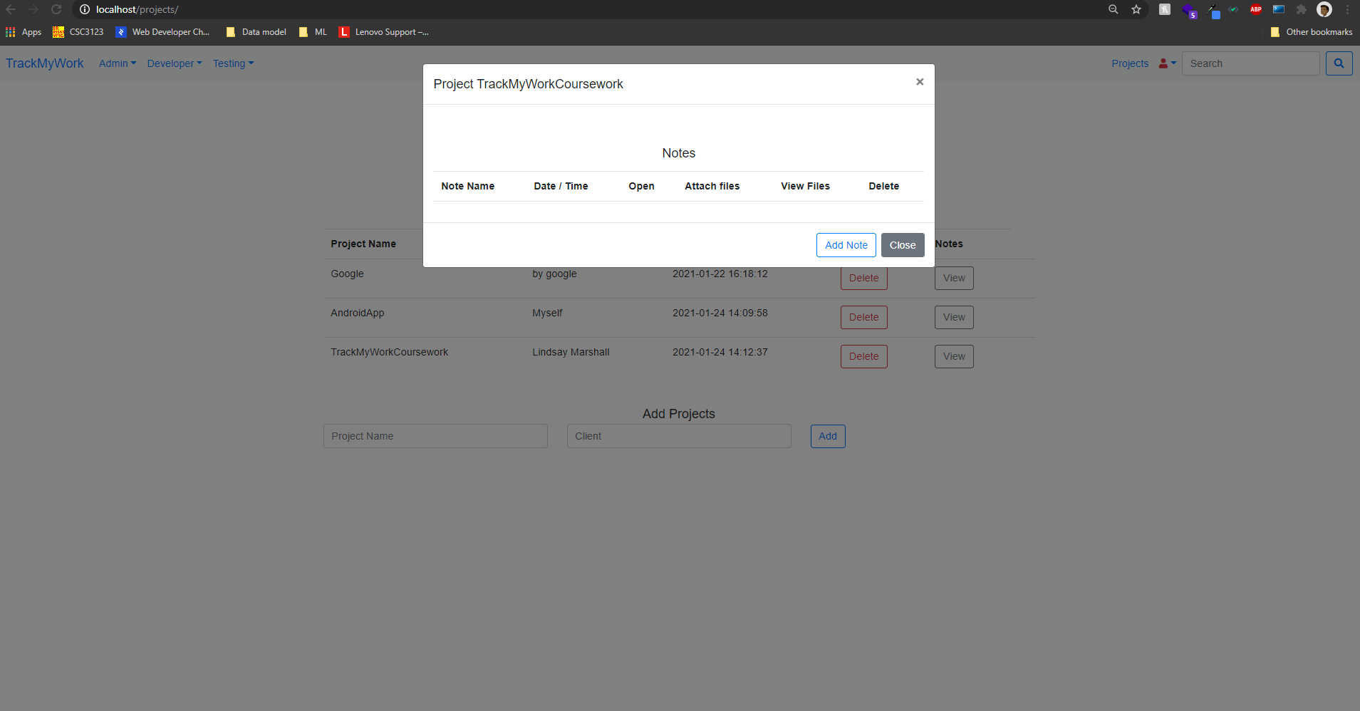

Here you can see that we don’t have notes for the TrackMyWorkProject so we might want to add some by clicking the **Add Note** button.

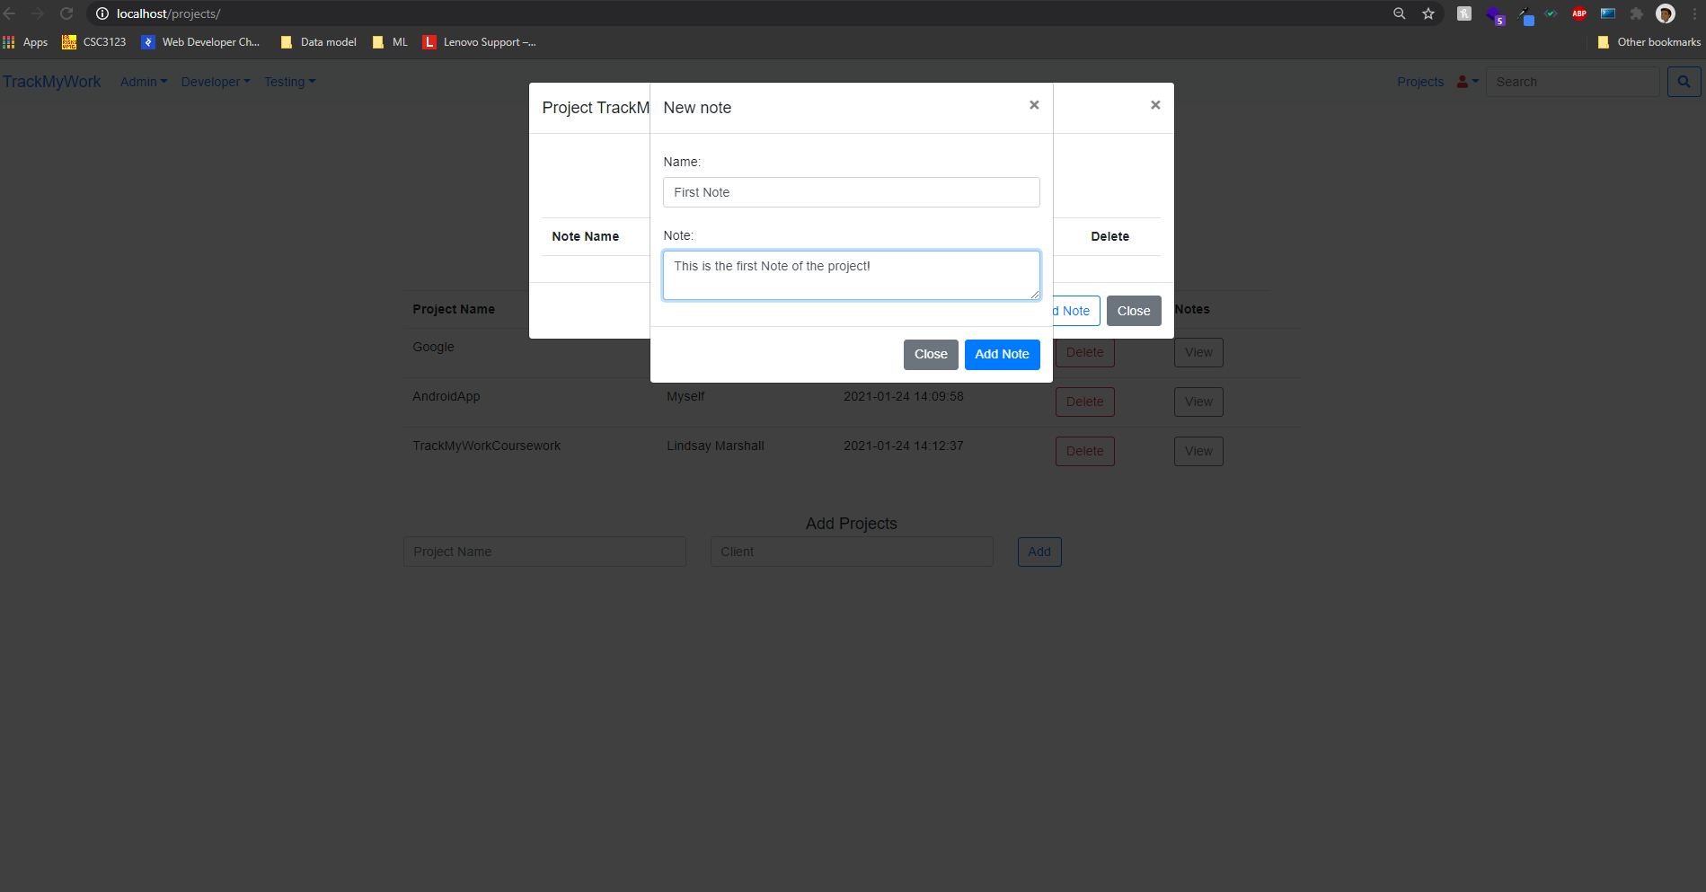

This allows us to add a new note to our project.

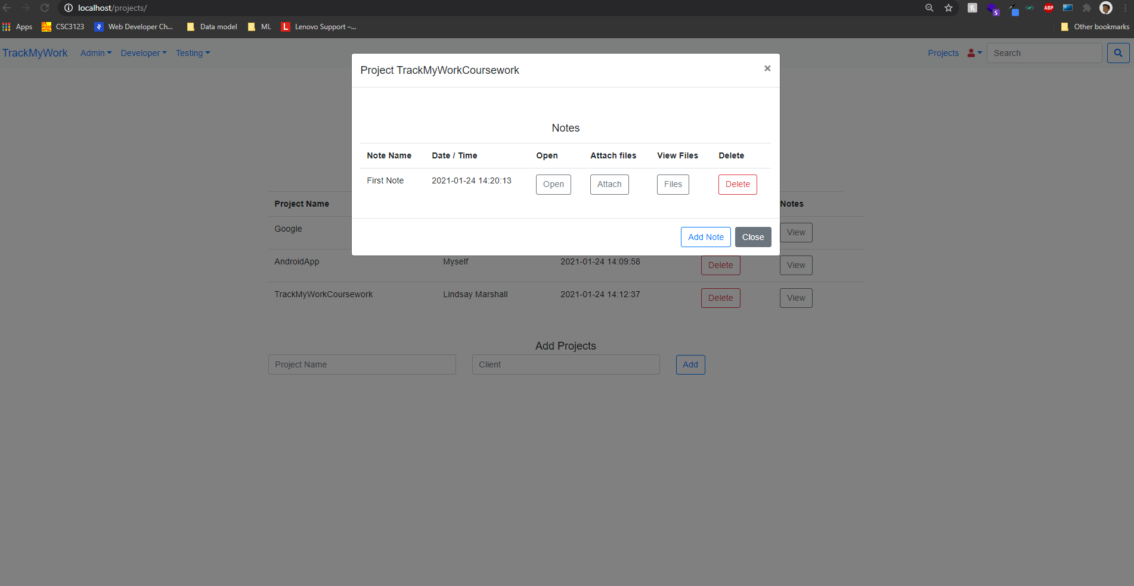

Here you can see the new note is being added to the project’s note.

And from here we have several options.

1.We can open and review the note.

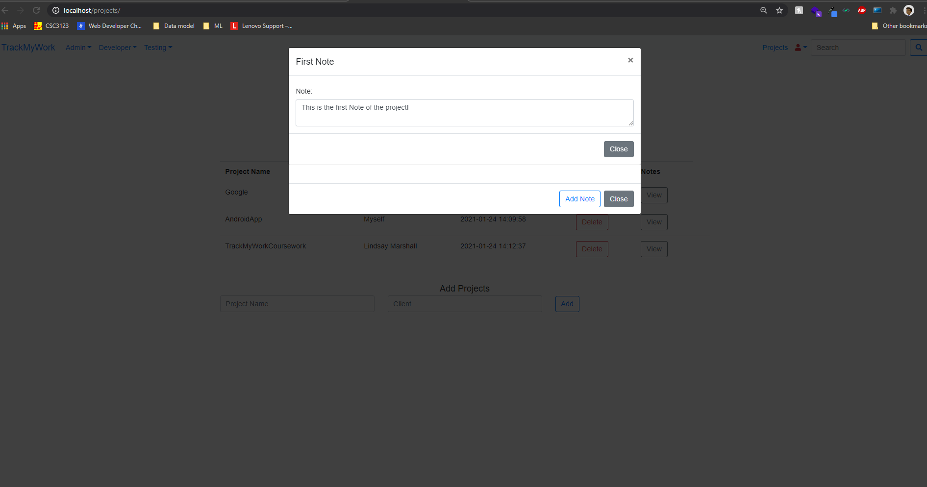

2.We can Attach files to the note by clicking the attach button,chosing a file and clicking upload.

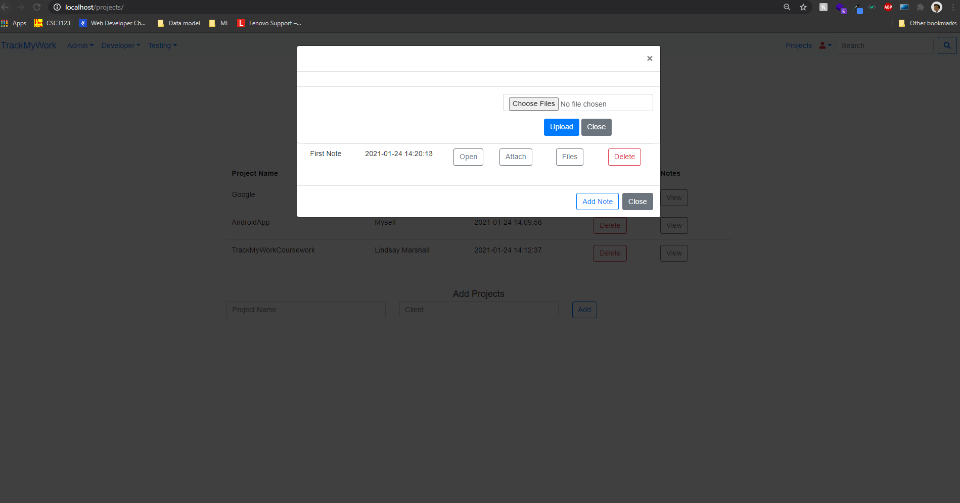

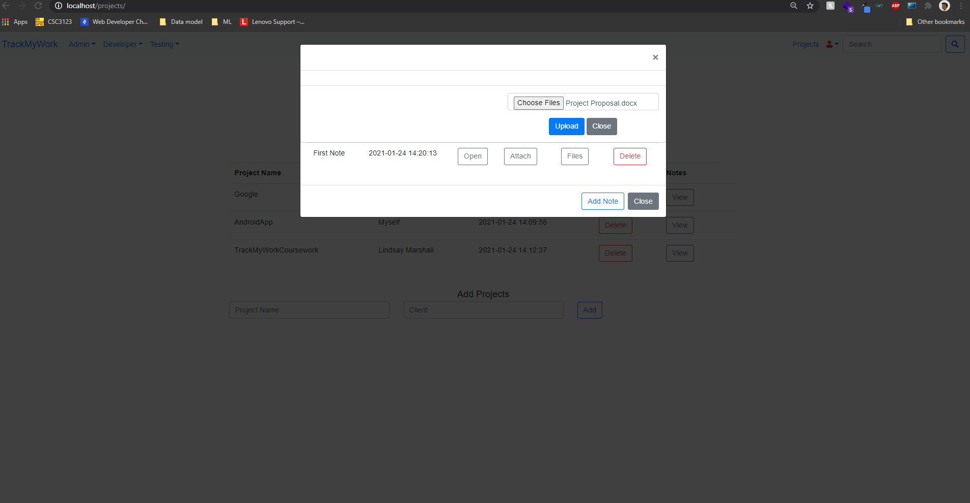

3.You can click on files to review the attached files for this notes.

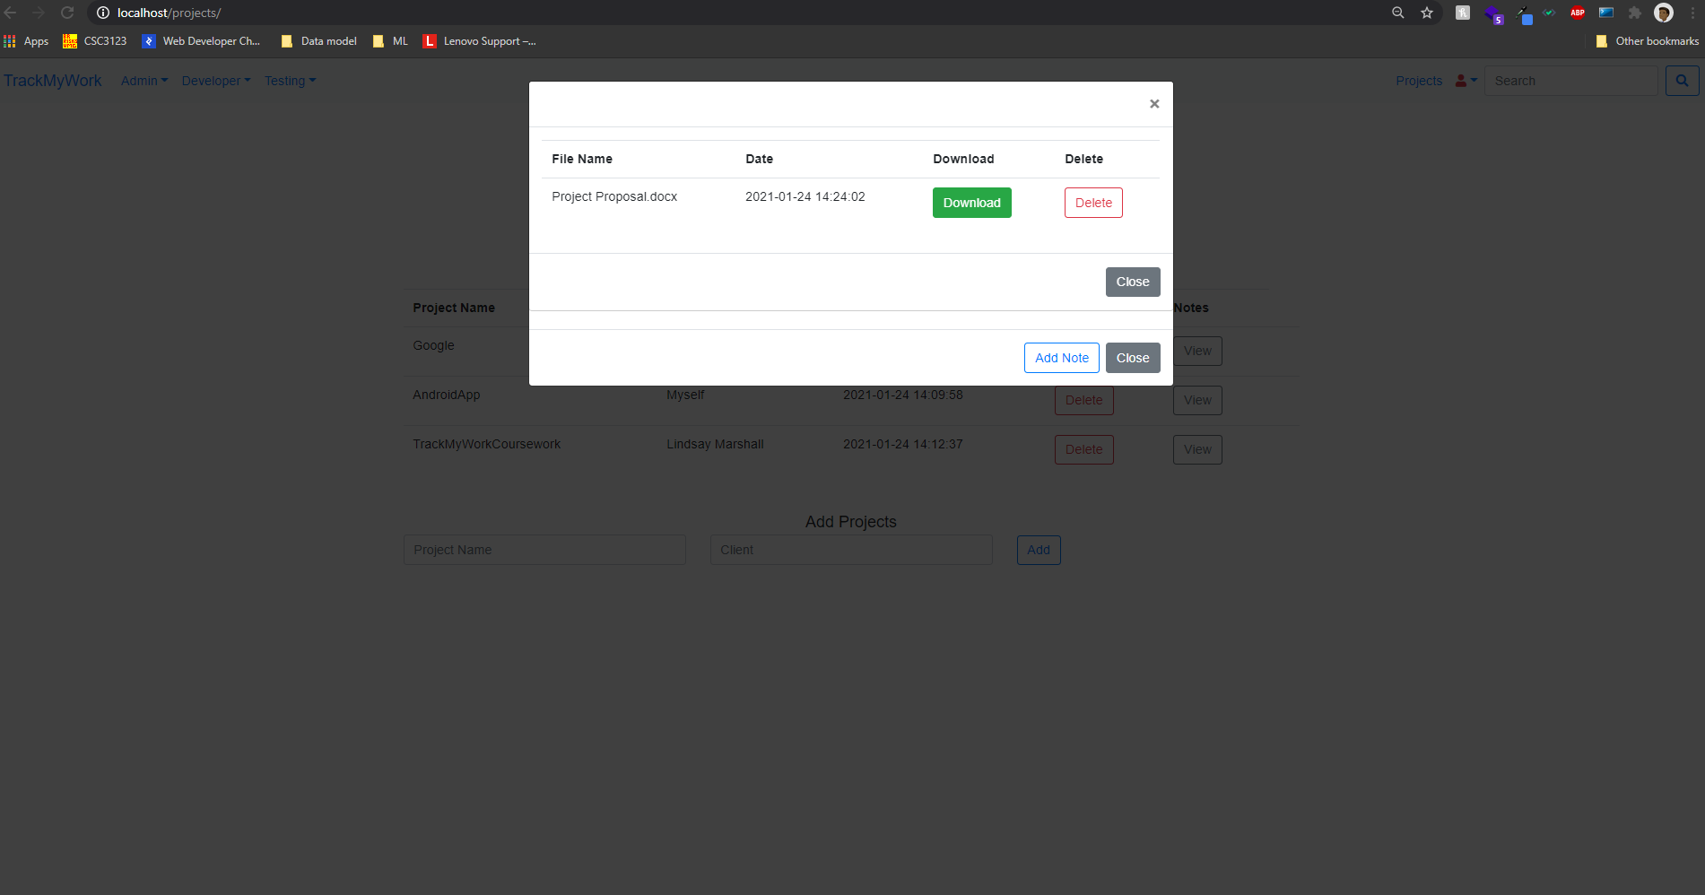

Here you can also retrive the files or delete them.

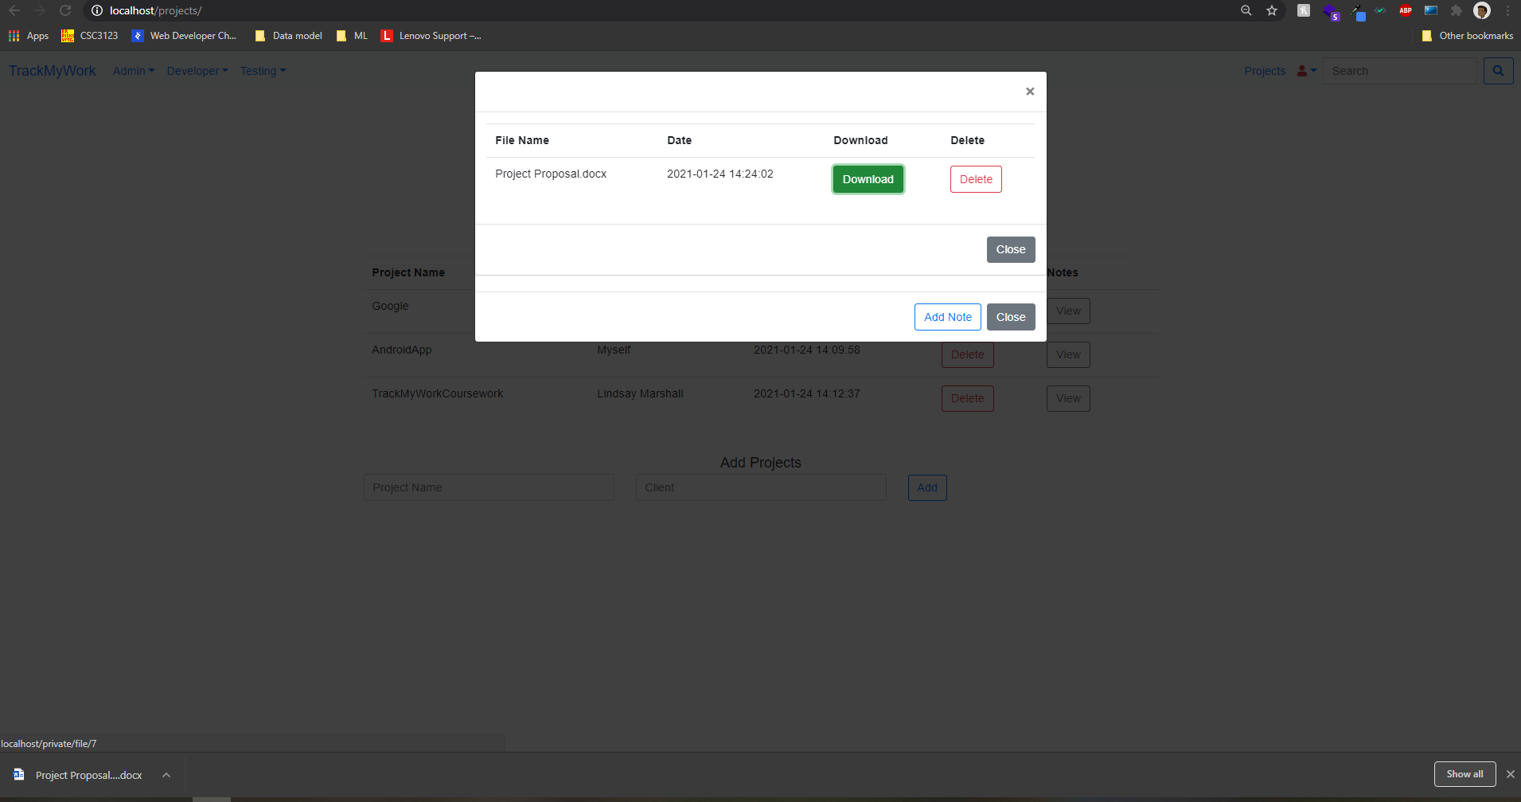

This happens if you click the download button.

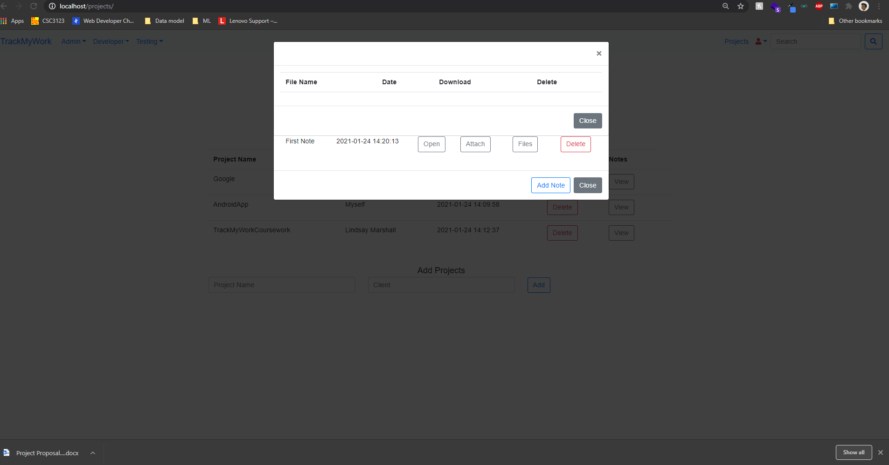

And If you click the delete button you can delete the files.

The same way you can delete notes and projects.